NAME: RAMYA RAMESH

USN: 1BM19CS227

**PROGRAM 1 = INSURANCE DATABASE**

create database insurance;

use insurance;

create table person(driver_id varchar(10),name varchar(10),address varchar(30),primary key(driver_id));

desc person;

create table car(reg_num varchar(10),model varchar(20),year int,primary key(reg_num));

desc car;

create table accident(report_num int,accident_date date,location varchar(30),primary key(report_num));

desc accident;

create table owns(driver_id varchar(10),reg_num varchar(10), primary key(driver_id,reg_num), foreign key(driver_id) references person(driver_id), foreign key(reg_num) references car(reg_num));

desc owns;

create table participated(driver_id varchar(10), reg_num varchar(10), report_num int, damage_amount int, primary key(driver_id,reg_num,report_num), foreign key(driver_id) references person(driver_id), foreign key(reg_num) references car(reg_num), foreign key(report_num) references accident(report_num));

desc participated;

insert into person values('A01','Richard','Srinivas Nagar');

insert into person values('A02','Pradeep','Rajajinagar');

insert into person values('A03','Smith','Ashoknagar');

insert into person values('A04','Venu','N.R.Colony');

insert into person values('A05','John','Hanumanth Nagar');

commit;

select * from person;

insert into car values('KA052250','Indica', 1990);

insert into car values('KA031181','Lancer', 1957);

insert into car values('KA095477','Toyota', 1998);

insert into car values('KA053408','Honda', 2008);

insert into car values('KA041702','Audi', 2005);

commit;

select * from car;

insert into accident values(11,'2003-01-01','Mysore Road');

insert into accident values(12,'2004-02-02','Southend Circle');

insert into accident values(13,'2003-01-21','Bull Temple Road');

insert into accident values(14,'2008-02-17','Mysore Road');

insert into accident values(15,'2005-03-04','Kanakpura Road');

commit;

select * from accident;

insert into owns values('A01','KA052250');

insert into owns values('A02','KA053408');

insert into owns values('A03','KA031181');

insert into owns values('A04','KA095477');

insert into owns values('A05','KA041702');

commit;

select * from owns;

insert into participated values('A01','KA052250',11,10000);

insert into participated values('A02','KA053408',12,50000);

insert into participated values('A03','KA031181',13,25000);

insert into participated values('A04','KA095477',14,3000);

insert into participated values('A05','KA041702',15,5000);

commit;

select * from participated;

TABLES:

1. person

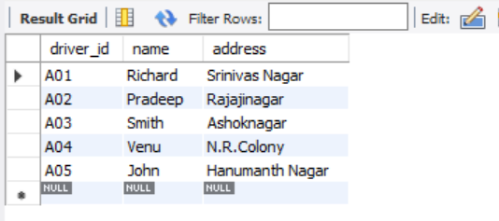

1. car

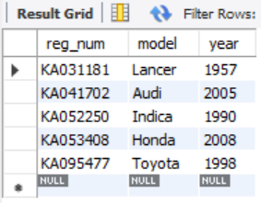

1. accident

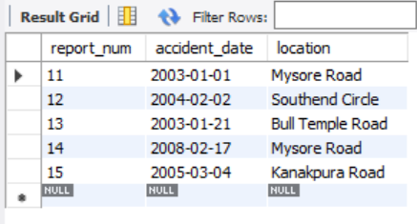

1. owns

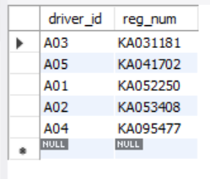

1. participated

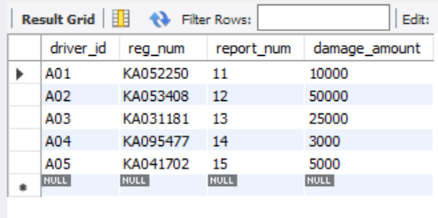

QUERIES:

1. Update the damage amount to 25000 for the car with a specific reg-num(example 'KA053408') for which the accident report number was 12.

update participated set damage_amount=25000 where report_num=12 and reg_num='KA053408';

select * from participated;

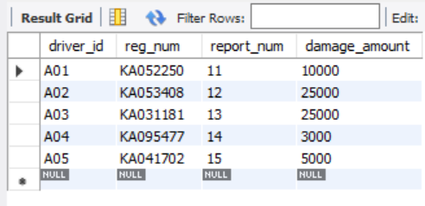

1. Add a new accident to the database.

insert into accident values(16,'2008-07-14','M.G Road');

insert into person values('A06','Rohit','Basavanaguddi');

insert into car values('KA018489','Santro', 2002);

insert into participated values('A06','KA018489',16,15000);

commit;

select * from accident;

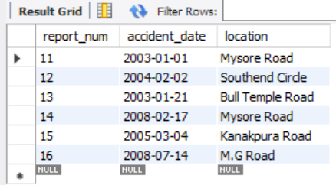

1. Find the total number of people who owned cars that involved in accidents in 2008.

select count(driver_id) from participated p,accident a where a.accident_date like '2008%' and p.report_num=a.report_num;

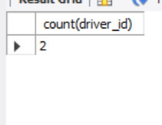

1. Find the number of accidents in which cars belonging to a specific model (example ‘Toyota’)were involved.

select count(*) from car c,participated p where c.reg_num=p.reg_num and c.model='Toyota';

